NAME:Rishik JK
REG.NO :192511052

CSA1702-ARTIFICIAL INTELLIGENCE
LAB EXPERIMENT

27. Prolog Program to Implement Best First Search Algorithm

1. Aim
To write a Prolog program to implement the Best First Search algorithm using heuristic values to find a path from the starting node to the goal node.

2. Algorithm
- Start the program.
- Define the graph and heuristic values.
- Begin from the starting node.
- Select the node with the lowest heuristic value.
- Check whether the selected node is the goal.
- If not, explore its neighboring nodes.
- Continue until the goal is found.
- Display the path.
- Stop
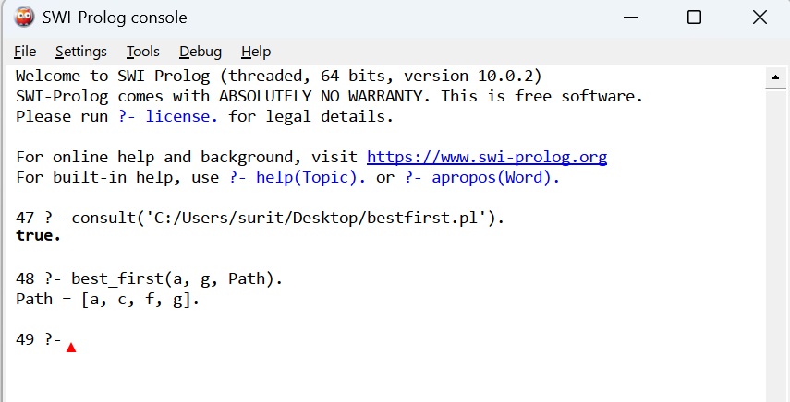

3. Result
Thus, the Prolog program to implement the Best First Search algorithm was successfully implemented and executed. The path from the starting node to the goal node was obtained using heuristic values.

